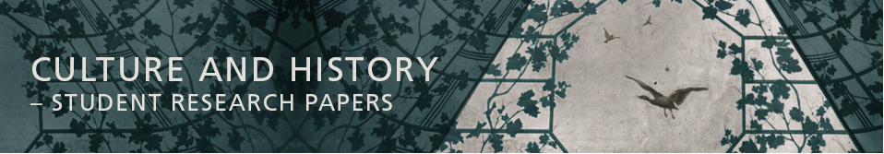
Instructions and guidelines for authors contributing to Culture and History – Student Research Papers
Culture and History is an online journal that publishes articles written by students at the Saxo Institute at the University of Copenhagen. The journal is published both as special and mixed issues and is edited by a permanent editorial board, in cooperation with guest editors when required. The board collectively makes decisions concerning incoming contributions and arranges for peer-review.
See the journal at:
https://tidsskrift.dk/index.php/culturehistoryku
The first issue can be read at:
https://tidsskrift.dk/index.php/culturehistoryku/issue/view/3797
Articles are to be submitted in the following format:
Length: Length of articles should be 10-15 pages (1 page equals 2400 characters including spaces). Contributions may be supplied with relevant photos or illustrations. Articles may be written in either Danish or English.
References:
Monographies
Author (surname, first name) year published: Book title in cursive. Publisher, publisher’s location if applicable (not with journal articles).
Example: Mikkelsen, Hans 1996: History of Dance. Cambridge University Press.
Chapters in anthologies
Chapter author (surname, first name) year published: “chapter title in double quotation marks”. Author/editor of anthology (first name, surname): Title of anthology in cursive, publisher, publisher’s location if applicable, page numbers.
Example: Mikkelsen, Hans 2007: “Dance in Early Modern History”. Svend Christensen (ed.): Danish Culture Studies,
Cambridge University Press, 63-88.
Journal articles
Author (surname, first name) year published: “article title in double quotation marks”. Journal title in cursive, volume number if applicable, page number.
Example: Mikkelsen, Hans 2008: “Dancing in the Middle Ages”. Culture Studies 2008:1, p. 33-46.
If the article is based on sources that have not been published, it should contain a list of “Unpublished sources”.
References and footnotes:
References should be given in-text as (last name year: page numbers if applicable). Example: (Mikkelsen 2008: 47). If referring to more than one work, a semicolon is added in between. Example: (Mikkelsen 2008: 46; Faraway 2005: 30). If referring to websites, the address is placed in brackets. Example: (www.ku.dk). Consulted websites should also be added in a complete list after the bibliography at the end of the article and are supplied with the date that the address was accessed. Notes are added as footnotes.
Abstract: The article must be supplied with an abstract of up to 100 words at the beginning of the manuscript.
Keywords: Articles must be supplied with 4-5 keywords following the abstract.
Author details: Must be placed at the end of the manuscript and must state author’s name, subject and email address.
Layout: Articles should be written in a permanent layout. The layout can be found as a Word document template (called Matrix C&H.docx). Authors can write in this template from the start or add their manuscript to the template after completion. Styles can be changed at the top when highlighting headers, body text etc. and clicking the correct styles.
The title of the article is called “typografi Overskrift 1”.
Subtitle is called “typografi manchet”.
Author name(s) is “typografi forfatter”.
Abstract is “typografi abstract”.
Section headings are “Undertitel – Afsnit overskrift”
Body text is “typografi Tekst Brød”.
Quotations are “typografi citat”.
Footnotes are “typografi fodnote”.
Bibliography is “typografi litteraturliste”.
When highlighting pieces of text and clicking on the correct styles at the top, font, font size and colours change to the correct versions.
Link to a separate document with the template ready for use can be found here.

